Solution Architecture

Date | 30 September 2026
Team ID | SWTID-2026-7969
Project Name | Streamlining IT Procurement: Automating Standard Laptop Orders with Flow Designer
Maximum Marks | 5 Marks

Solution Architecture Diagram:
Provide a high-level visual representation of your solution's architecture. Use the structural layout below as a template to map out your Presentation Layer, Application Layer, and Data Layer. Fill in the specific technologies and components for your project directly into the boxes to create your architectural diagram.

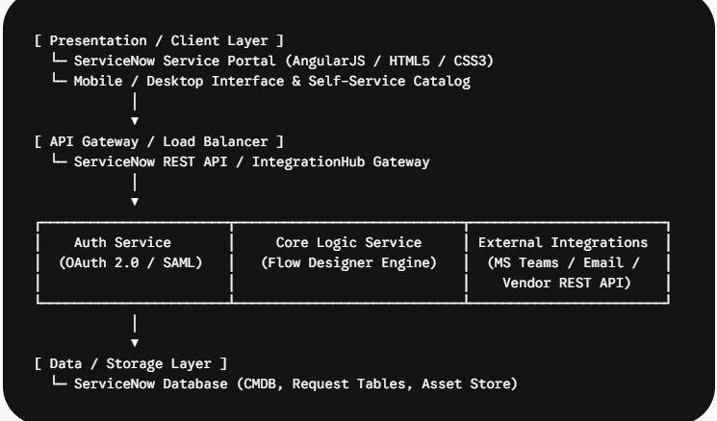

Component Description Table



